Good Friday Kids
Activities and Resources
Activity | Resources | Instructions/Picture
Painted Stones | - Large pebbles  - Paint brushes  - Acrylic paints  - Sharpies (for writing)  - Paper towels  - Hand wipes | 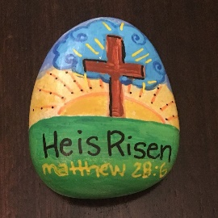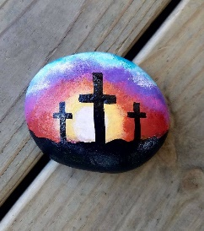
Stained Glass Crosses | - Black card cross templates  - Coloured tissue paper or coloured cellophane  - Glue sticks | 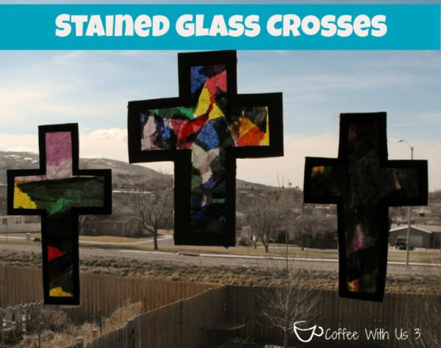
Opening the Real Easter Egg | - 2 Paper Plates  - Black Paper  - Yellow Paper  - 2 craft pins  - Paper and pencils to decorate an Easter egg  - Scissors  - Glue | Cut out the light from the Yellow Paper and glue it to the first plate. Cut out the cross from the Black Paper and glue it over the light.  Draw and decorate an Easter egg and glue it on the front plate. Cut the plate down the middle. Attach with pins to the first plate so that it slides open.  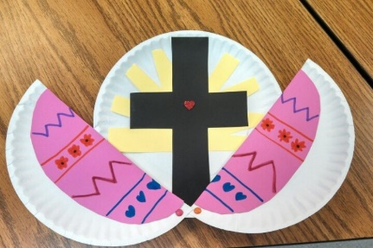
Jelly Bean Prayer | - Jelly Beans  - Plastic eggs  - Jelly bean prayer sheet | 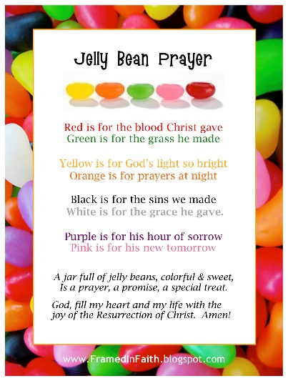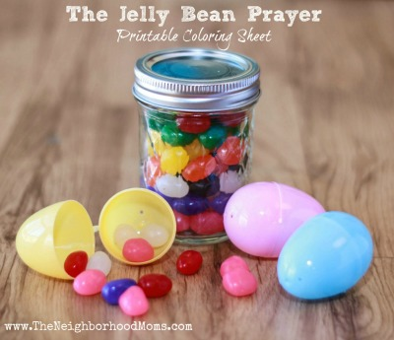
Easter Story Cube | - Printouts  - Scissors  - Colouring pencils/pens  - Glue sticks | 