Light Party Games and Crafts Ideas

Keeper of the Keys

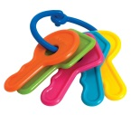
Set up one chair in the middle of the room and have the room dimly lit
One person is blindfolded and sits on the chair holding a torch
A bunch of keys is placed under the chair
Everyone takes it in turns to try and steal the keys from under the chair
If the keeper of the keys thinks they know where the thief is they are to shine their torch to see if they can ‘hit’ the thief with the beam
If they are successful the keeper and thief swap places

Prayer Lanterns
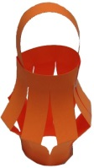
Cut slits into a rectangular strip of paper so that the cuts don’t go all the way through. (There is a template if you would like to print it). Before you have joined the lantern into the round, explain to the children that Jesus came as a light to shine for everyone. On each strip, ask the children to write down the names of people that they would like Jesus’ light to shine on.
Then fold the paper in half (lengthways) so that the strips you’ve cut bend outwards when it’s joined together. Join the paper into a round and secure it with tape to make a lantern, I cut off the edges of the paper to make a handle
Once the lanterns are made, ask everyone to hold up their lantern and say a prayer for all the people written on them:

‘Dear Jesus, you came to shine your light on us. Shine brightly on every person that we’ve named on our lanterns, and help us all remember your light when it is dark. Amen.’

Treasure Hunt

Hide CDs around the house, shiny side uppermost, alternatively use pieces of tin foil. Turn off the lights, maybe leaving on a few LED nightlights or fairy-light chains for safety. The children must find the CDs using a small torch to see the way, which will reflect off the CD or foil if it’s placed shiny side up.

Making Shadows

Try making some of these animal shapes on the wall with your hands and a torch

A butterfly 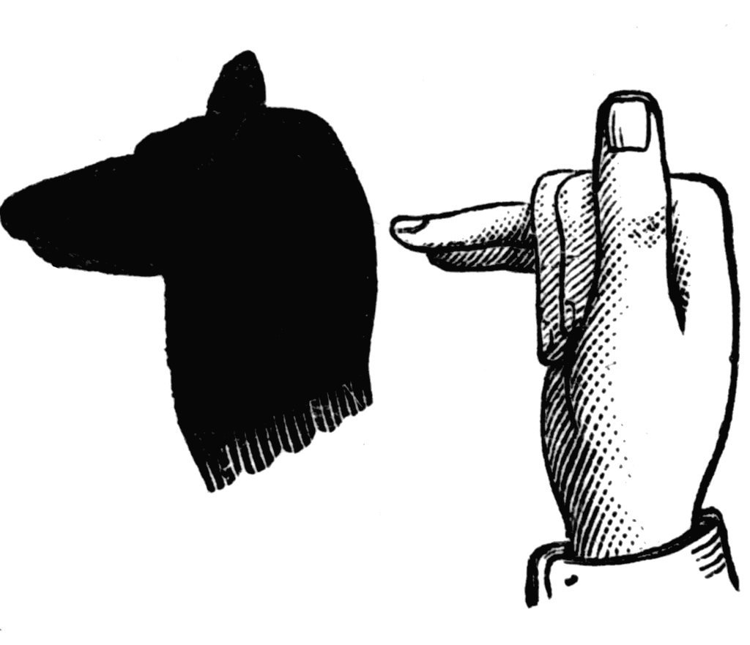 A dog A camel 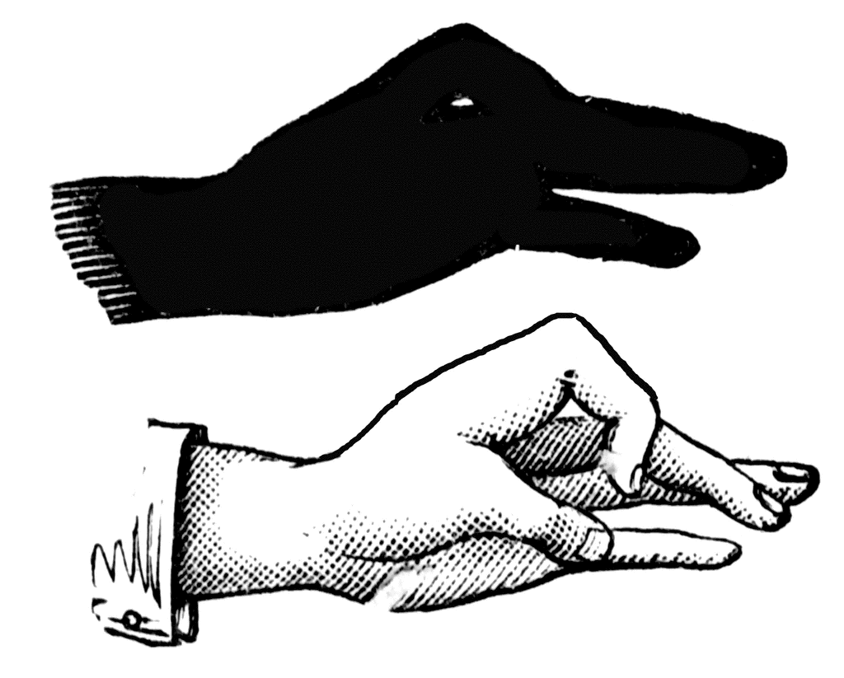A goose

Edible Candles
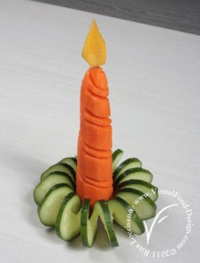
The base is made of a spiral of cucumber. The candle is a carrot and the flame at the top is a piece of swede, or you could use the tip of a baby sweetcorn

