FAITH AT HOME1. A BROKEN DOWN WALL
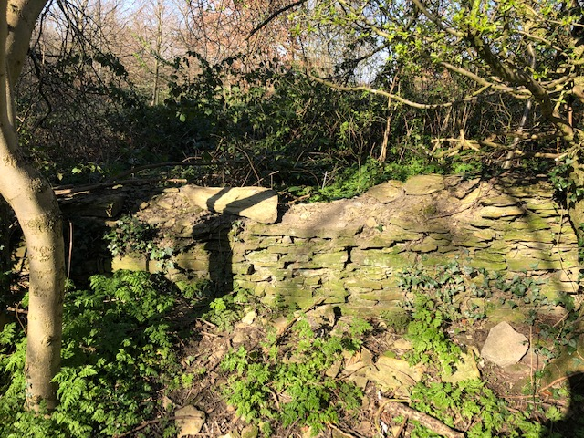

If you found a wall to take a photo of, did you wonder WHY it was falling down? Do you think no-one looks after it anymore?
Could people or animals climb over it easily now that it has fallen down?
READ THIS STORY FROM THE BIBLE ABOUT A MAN CALLED NEHEMIAH
You can read the whole story in the Bible, if you have one. The book of Nehemiah 1-7:3
Or, read this version
https://bibleforchildren.org/PDFs/english/The_Great_Wall_of_Nehemiah_English.pdf

Talk about some of these things
- Do you think Nehemiah was right to let the King see that he was sad? Do you think you would be sad if your town or city was falling down?
- Why do you think that lots of the people were so keen to help?
- What reasons can you think of to explain why Sanballat, Tobiah and Geshem didn’t want the wall to be built?
- Some of the workers had to be guards too. How hard would it be to build a wall and hold a sword too?
- How do you think everyone felt when the walls were finished?
ACTIVITIES TO DO
1. BUILDING Find something to build with. It could be lego, duplo, wooden blocks, jenga pieces.
Put one hand behind your back. Now using the other hand, how high can you build a wall in one minute? Ask someone to time you. If it falls down you must start again!
Nehemiah’s builders had to build with one hand and hold a sword in the other hand in case someone attacked!
2. PERSEVERANCE Play the board game (attached) You will need a counter for each player and a dice or spinner.
3. LUNCHTIME Nehemiah could have bought himself special food, he was the leader so he could have demanded all his favourite things to eat. Use the two circles on the next page and draw two lunches. One very simple, like the workman would have, and one with all your amazing favourite foods. Which one did Nehemiah choose? Why do you think he did this?

PRAYER to finish.
You can make this prayer your own.
Thank you God that Nehemiah did these amazing things (say some of the things he did)
Help me to learn from what he did and to listen to you.
Amen

Draw two lunches

